19 mm Econo Range Single Upright Expandable Door.



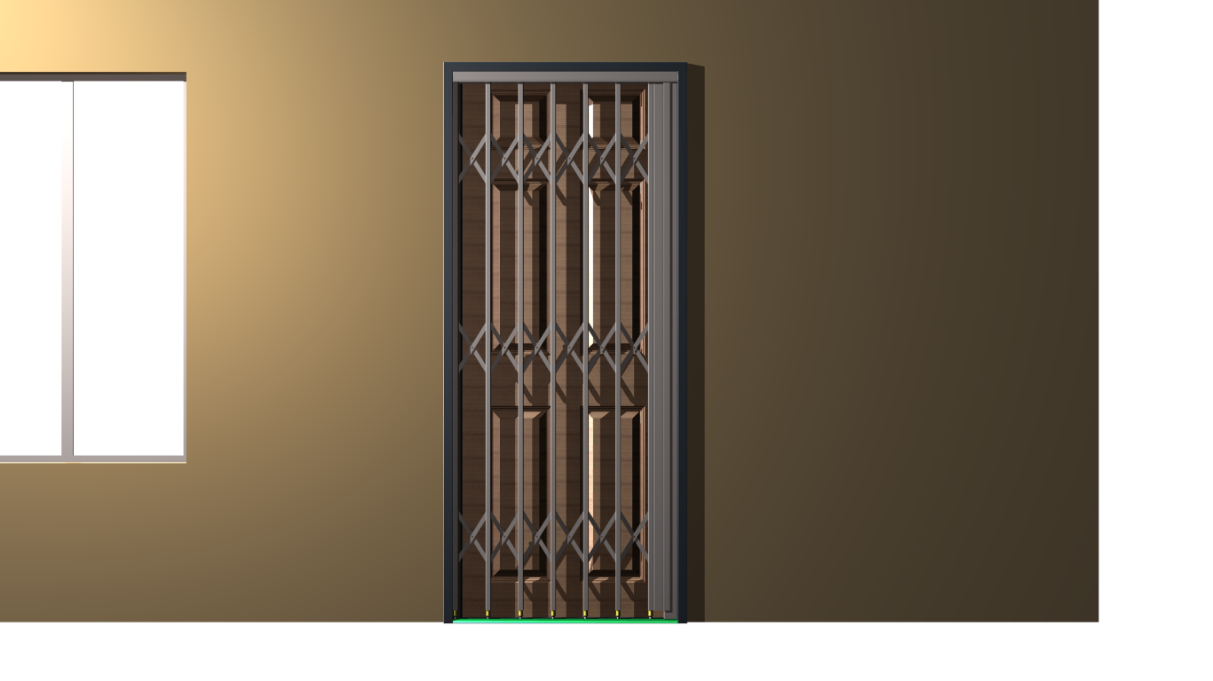

Top Track manufactured from Galvanized Material. Double rolled lip for ultimate strength. Uprights supported with sealed Stainless Steel Bearing

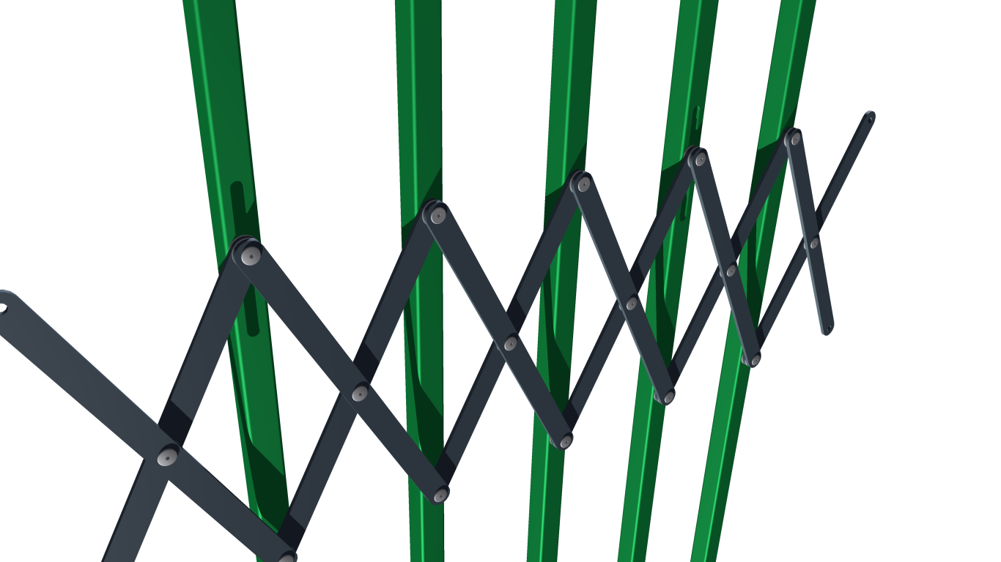

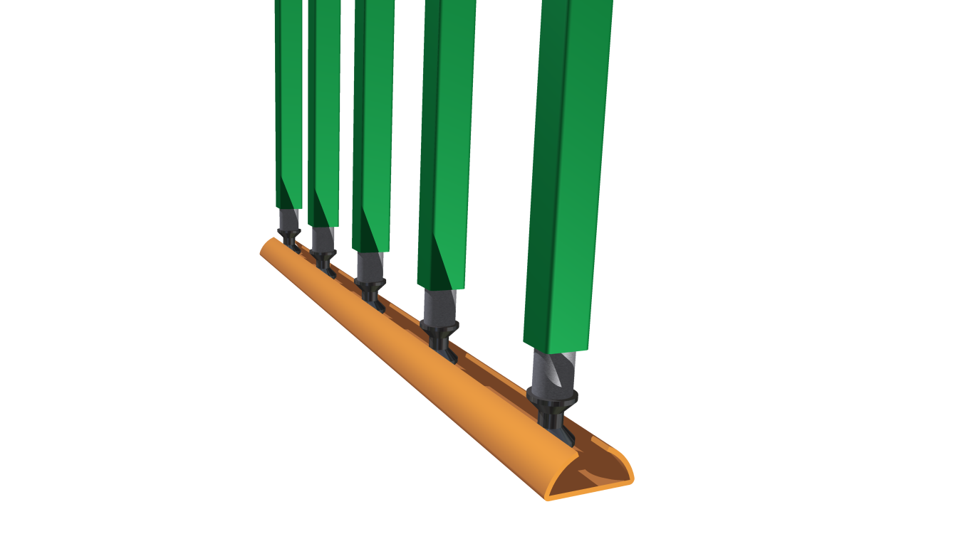

19mm Single Upright with Flight Guide protected inside uprights

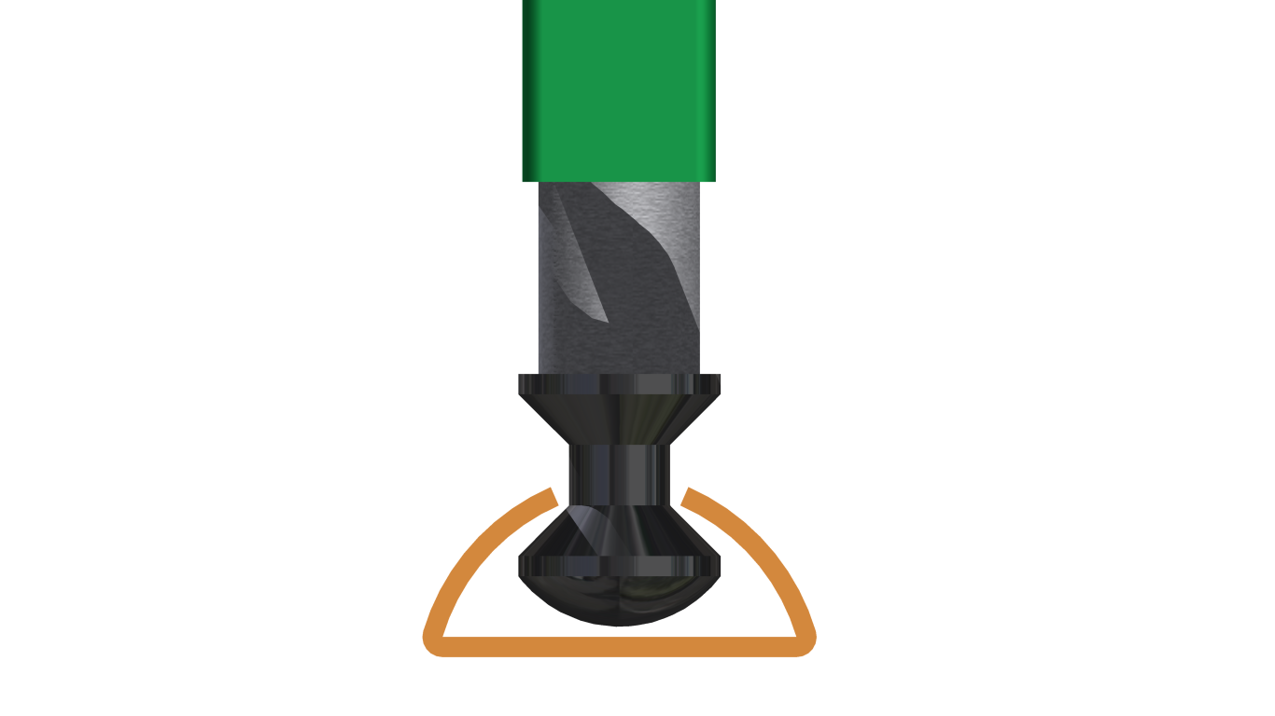

Galvanized Steel Tube

NYLON BOTTOM RUNNER

Standard Galvanized
Steel Bottom Track

